**UNIT 3**

**CIRCULAR FLOW OF INCOME AND NATIONAL INCOME ACCOUNTING**

* Circular Flow of Income

The modern economy is a monetary economy. In the modern economy, money is used in the process of exchange. Money has facilitated the process of exchange and has removed the difficulties of the barter system. Thus, money acts as a medium of exchange.

* **Circular Income Flow in a Two-Sector Economy.**

1. Without Savings and investment

We assume that all incomes which household receive are spent on consumer goods & services and thus there is no savings by them. Similarly, we assume that there are no investments by business firms. Money flows of income and expenditure corresponding to the real flow in terms of goods, services and productive factors.

In the upper loop, the resources such as land, labor, capital and entrepreneurial ability flow from households to business firms as indicated. In the opposite direction to this, money flows from business firms to households in the form of factor payments such as wages, rent, interests and profits.

In the lower loop, money flows from households to firms as consumption expenditure made by the households on the goods & services produced by the firms, while the flow of goods & services is in the opposite direction from business firms to households. Thus, we see that money flows from business firms to households as factor payments and then it flows from households to firms as consumption expenditure.

1. With Saving and Investment

When households save, their expenditure on goods & services will decline to that extent and as a result money flow to the business firms will contract. In free market economies there exist a set of institutions such as banks where household deposit their savings. It is business firms who borrow from the financial institutions for investment in capital goods such as machines, factories, tools, etc. Firms spend on investment in order to expand their productive capacity in future. Thus, through investment expenditure by borrowing the savings of the households deposited in financial institutions are again brought into the expenditure stream.

In a simple economy which has neither government, nor foreign trade, the value of output produced which we denote by Y is equal to the value of output sold. Since the value of output sold is equal to the sum of investment and consumption expenditure, we have

…….…………..(1)

Now, income in the simple economy from the viewpoint of its allocation can be seen as addition of consumption expenditure and savings, we have

………………..(2)

From 1 & 2

Thus, the above equation shows that the value of output produced or sold is equal to the total income received. It is the income received that is spent on goods & services.

Thus, in a two sector simple economy with neither government nor foreign trade, investment is identically equal to savings.

Here, investment is considered as an injection (inflow of fund) and savings is considered as leakage from the money expenditure flow.

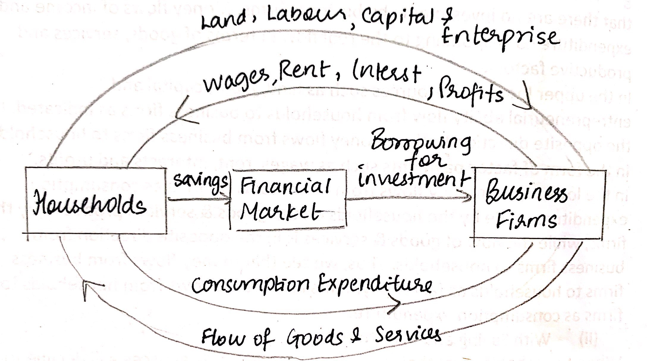

* **Circular Income Flow in a Three-Sector Economy.**

Government absorbs a good part of the income earned by households. Government affects the economy in a number of ways. Government purchases goods and services just like as households and firms do. Government expenditure takes many forms inclosing spending on capital goods and infrastructure and education and public health. These add to the money flow.

Government purchases goods & services from firms and households are seen as flow of money spending on goods & services. Government expenditure may be financed through tax, out of assets or by borrowing. The money flow from households and business firms to the government is labelled as tax payments.

Total expenditure flow in the economy is now the sum of consumption expenditure ©, investment expenditure (I) and Government expenditure (G).

Total income received (Y) is allocated to consumption (C), savings (S) and taxes (T).

Since expenditure (E ) must be equal to income received, we get

Therefore,

By arranging, we get

It signifies that if the government budget is not balanced i.e. if government expenditure (G) is greater than tax revenue (T), the government will have a deficit budget. To finance the budget deficit, Government will borrow from financial market. For this purpose, private investment (I) by business firms must be less than the savings (S) of the households. Here, tax revenue (T) is a leakage and Government Expenditure (G) is an injection.

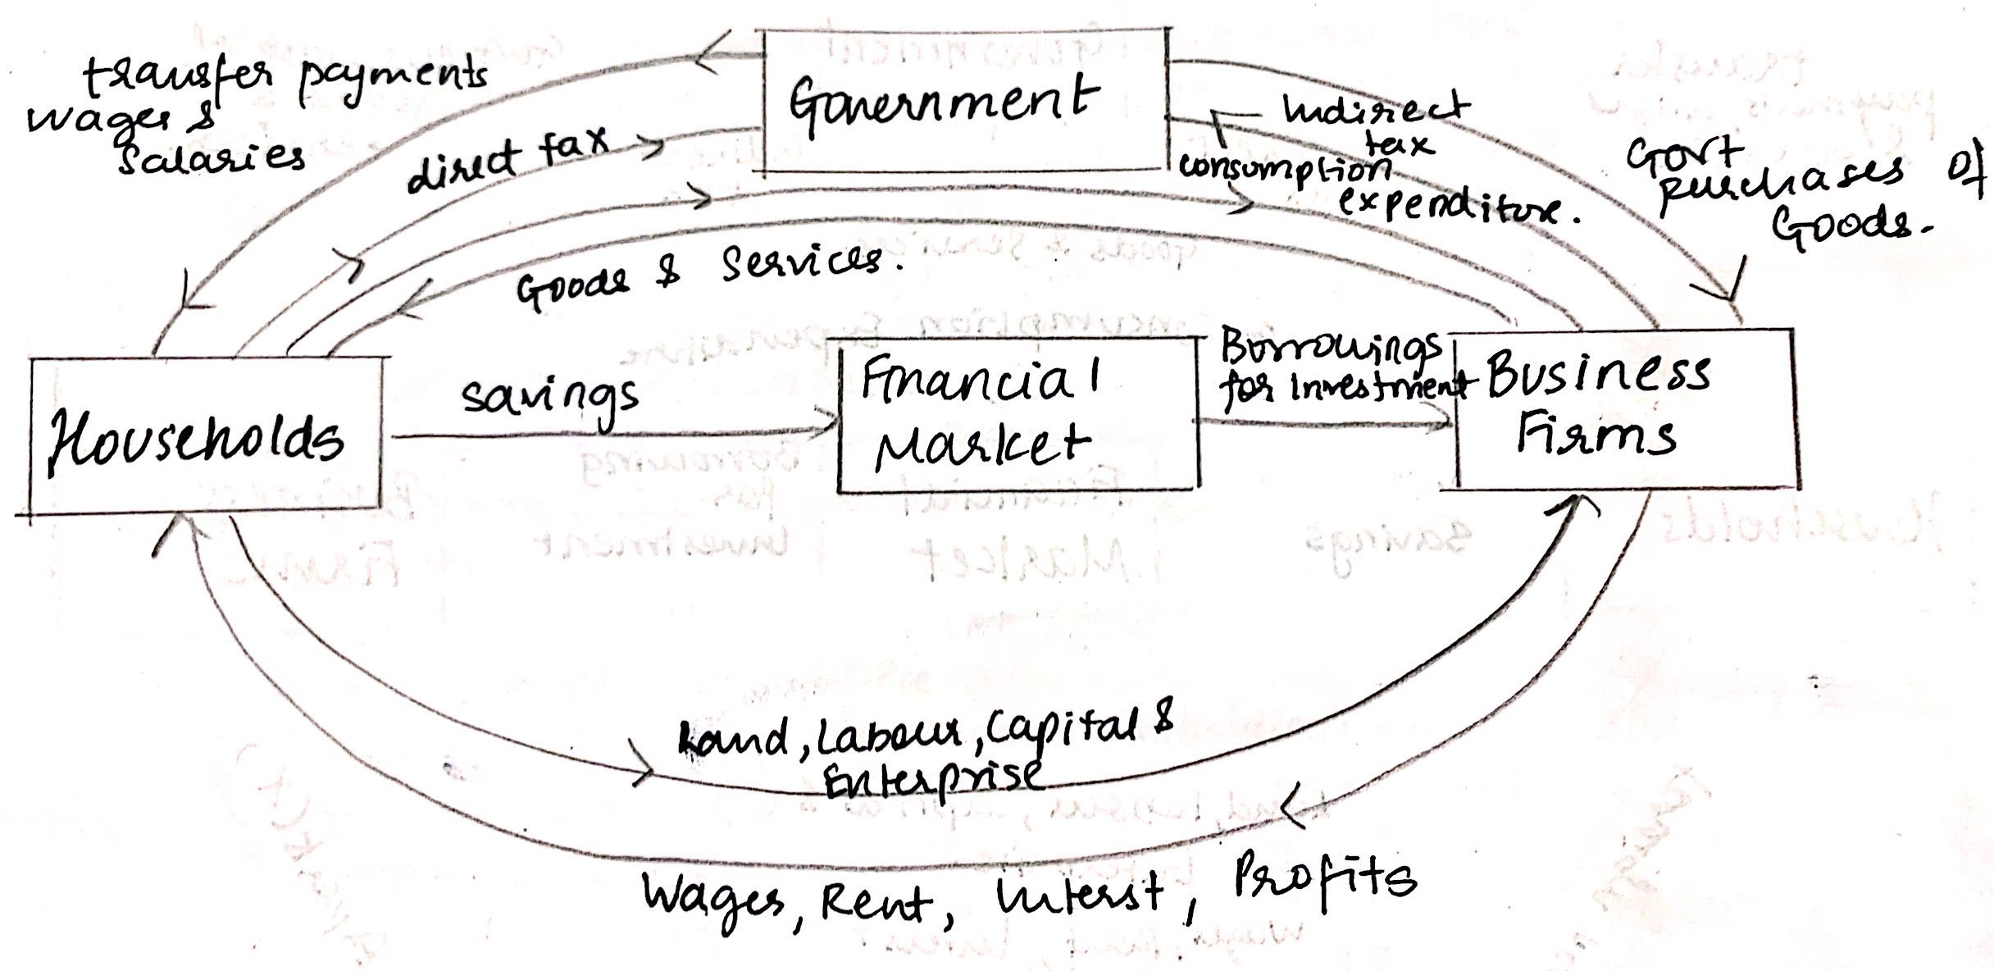

* **Money Flow in the Four-Sector Open Economy**

Here, we consider an economy which has trade relations with foreign countries. Foreigners interact with the domestic firms and households through exports and imports of goods and services as well as through borrowing and lending operations through financial markets.

The business firms of the domestic territory interact with foreign countries through export and import of goods & services. On the contrary, flow of money expenditure on exports of a domestic economy takes place from foreign countries to the business firms. If exports are equal to imports then there exist a balance of trade.

The households provide the foreign counties manpower and in return the households receive income in the form of foreign remittances.

From the circular flow, the national income can be measured as

Since national income can be either consumed, saved or paid as taxes, we have

Thus, we get

The above equation shows that in the open economy, sum of investment, govt. expenditure and net exports is equal to the sum of savings and tax revenue.

Here, imports (M) is a leakage and exports (X) is an injection.

Thus, the stability condition or the equilibrium condition is: -

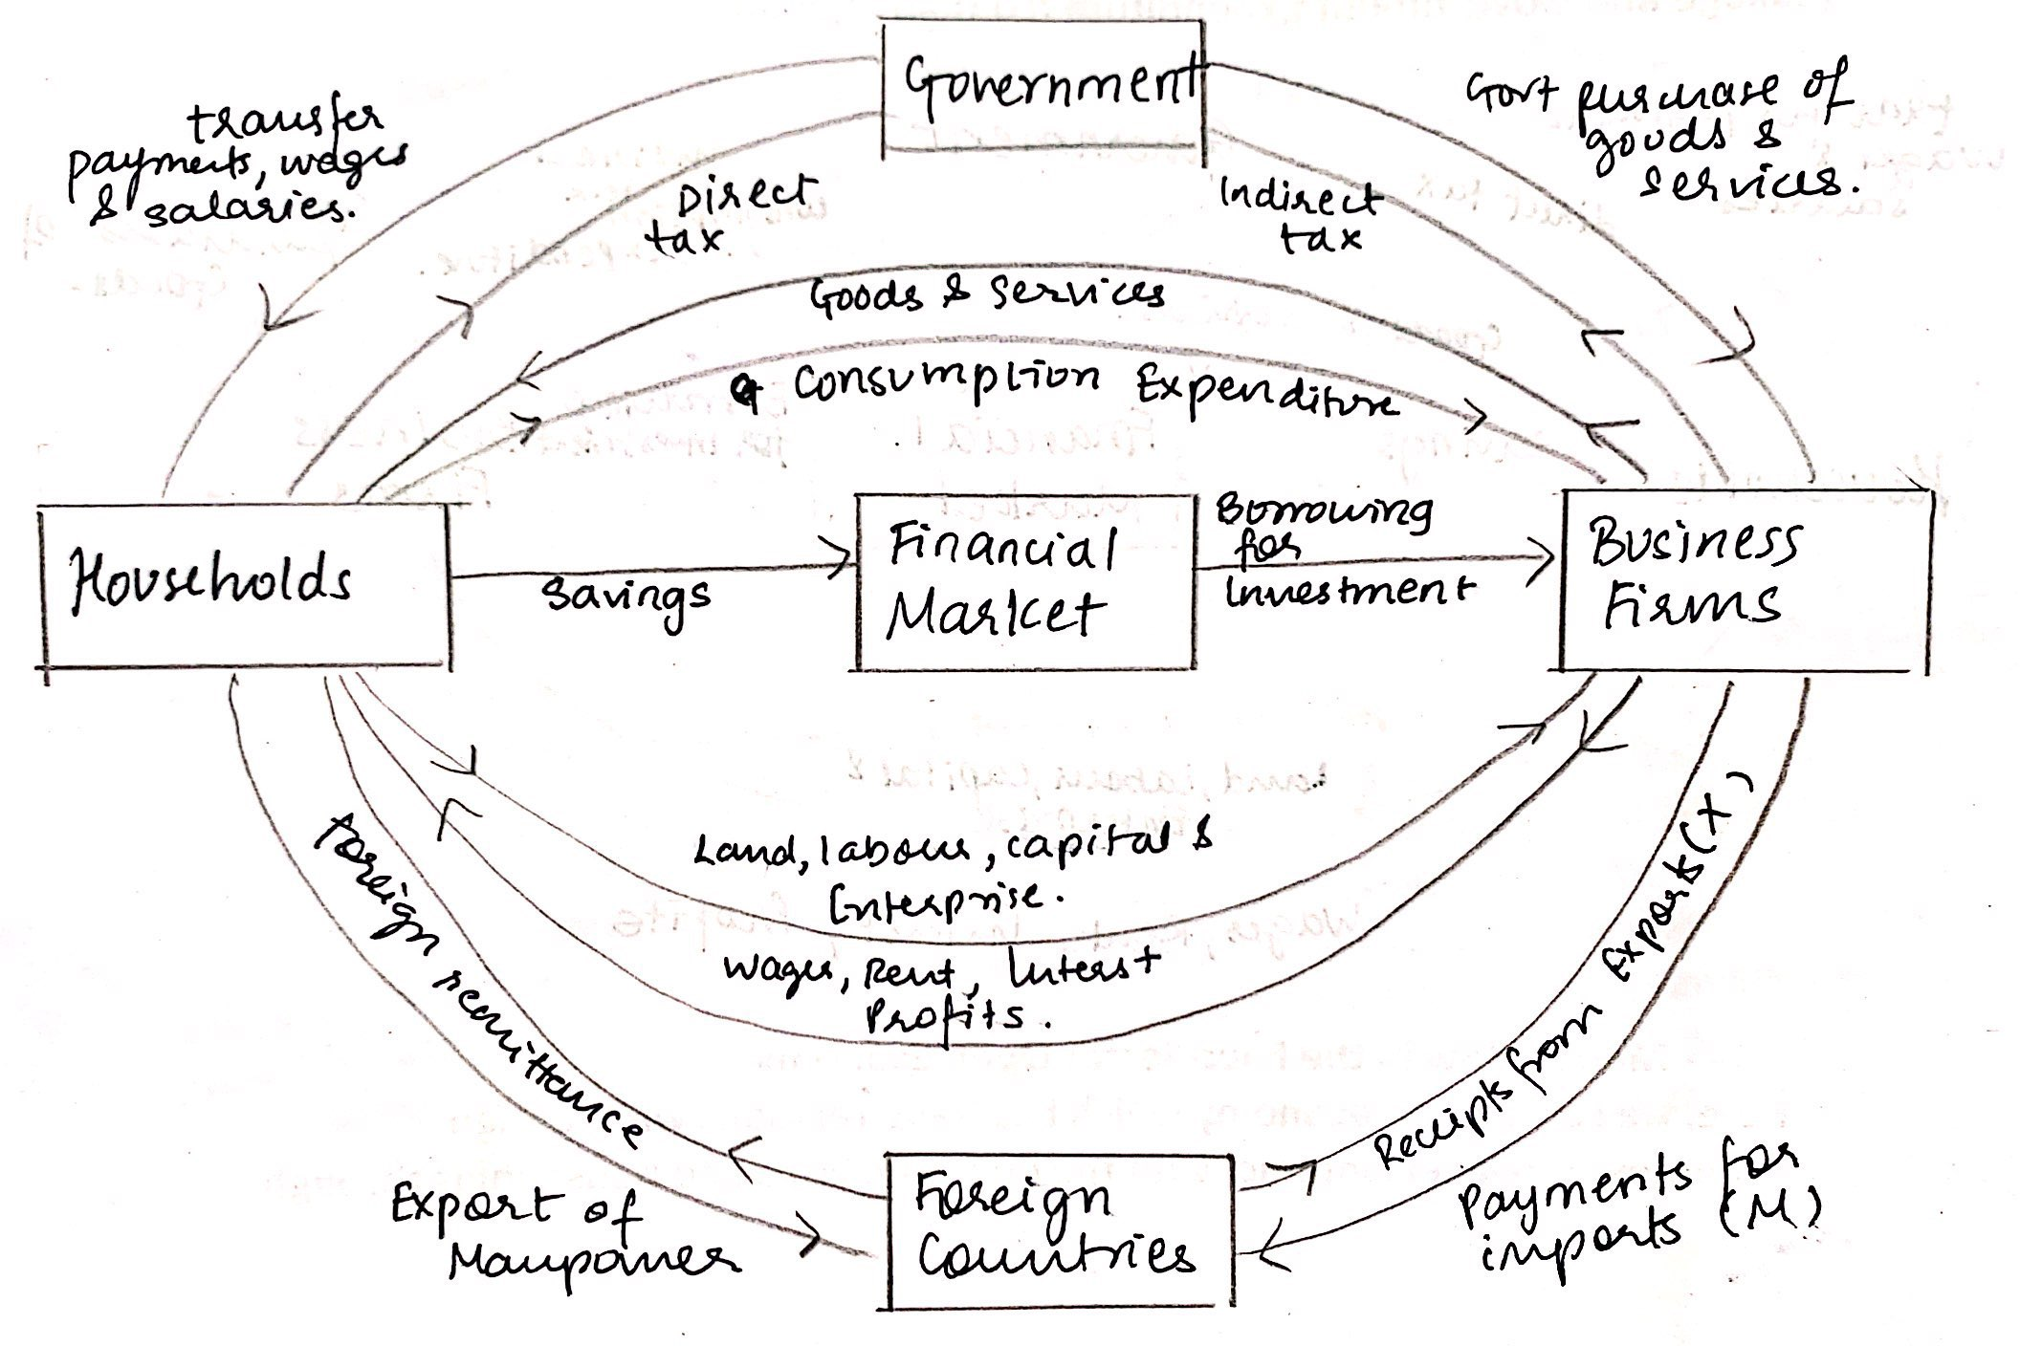

* National Income Accounting

National income of a country is defined as the total market value of all final goods & services produced in the economy in a year.

* **Gross Domestic Product GDPMP**

It is defined as the total market value of all final goods & services produced in a year in the domestic territory of the country.

GDP has following components: -

1. Value of final consumer goods & services produced in a year and consumed by the households (C)
2. Value of new capital goods produced and addition to the inventory of goods such as raw materials, semi-finished goods etc. (I)
3. Value of purchases of goods & services by the government (G)
4. Net exports (NX) which is equal to the value of goods exported minus the value of goods imported.

* **Gross National Product GNPMP**

It is the money value of all final goods & services produced by residents as well as non-residents in the domestic territory of a country and also the net factor income from abroad.

The net factor income from abroad is the difference between factor income received from abroad by residents of India for rendering factor services in other countries as well as factor incomes payed to the foreign residents for factor services rendered by them in the domestic territory of India.

* **Net Domestic Product NDPMP**

It means the value of all final goods & services produced in a year after providing for depreciation (reduction in the value of fixed assets due to its wear & tear).

* **Net Domestic Product NDPFC**
* **Net National Product NNPFC (National Income)**
* **Personal Income**

It is the sum of all incomes actually received by all individuals/households during a given year.

* **Personal Disposable Income**

After a part of personal income is paid to the government in the form of personal taxes like income tax, personal property tax etc, what remains of personal income is known as personal disposable income.

* **Nominal GNP and Real GNP**

Nominal GNP is the money value of all final goods & services produced at current prices. However, it does not truly indicate the performance of an economy over a period of time if prices are changing. This is because nominal GNP maybe increasing due to rise in price level, but the quantity of goods & services produced may remain constant.

The real GNP is money value of all final goods & services produced at constant prices i.e. the prices in the base year.

The calculation of real GNP helps to know whether the availability of goods & services in an economy has increased or not over a period of time. By calculating the percentage change of real GNP, it enables us to measure real the rate of economic growth in a year.

With the help of nominal GNP and real GNP we can measure rate of inflation. The rate of inflation is measured with the help of GNP deflator

* **Green GNP**

In estimating national income, the costs of pollution of air and water by the firms in the production process of goods & services must be subtracted to arrive at ‘Green GNP’.

Conventional national income accounting does not take into account the depletion of natural resources such as forests, coal, oil and natural gas, etc. The depletion of natural resources should be treated as a type of negative inventory investment which if accounted for in national income accounting would tend to lower the GDP estimates. The damage caused by cutting trees and thereby destroying forest and causing soil erosion can be assumed and accordingly proper deduction is made in estimation of real GNP.

If the growth of green GNP is attained, then the economic growth will promote social welfare and protect them from health hazards. For such growth to occur, environmental and ecological consequences of growth activities must be taken into account. This will ensure environment sustainability and thereby will promote the welfare not only of the current generation but also future generations.

**INFLATION**

Inflation is a persistent rise in the general price level rather than a once for all rise in it. Deflation represents persistent fall in prices.

According to Prof. Crowther – “*Inflation is a state in which the value of money is falling i.e. price is rising*.”

According to A. C. Pigou. – “*Inflation exists when money income is expanding more than in proportion to income earning activity*.”

* Concepts of Inflation

1. **Single Digit & Double Digit Inflation**

* Single Digit Inflation (0.01%-9.99%) per year has become almost a normal feature in most of the countries. It is also known as moderate inflation.
* People and authorities become concerned when double digit inflation (10% & above) per year occurs. It is also known as running inflation.

1. **Headline & core inflation.**

* Headline inflation is a measure of total inflation within the economy. It is the current rate of inflation at which prices are rising. It is measured on the basis of Wholesale Price Index (WPI).
* Core inflations is a measure of inflation which excludes temporary price fluctuations in case of commodities such as food items, fuel prices and energy products.

Core Inflation (CI) = Headline inflation (HI) – food & fuel prices (FF)

1. **Food Inflation**

* It is calculated based on the prices of food articles in the primary articles group and manufactured food products group. Primary food articles group includes rice, wheat, pulse, milk, fruits, eggs, vegetables etc. Under manufactured food products group we have tea, sugar, coffee etc.

1. **Retail Inflation**

* It is measured on the basis of consumer price index (CPI). It measures price changes from the prospective of retail buyer. It reflects the inflation borne by an individual consumer. In India, we have consumer price index for urban, rural and for labourers of different sector.
* Measurement of Rate of Inflation

**Rate of Inflation (∏) is equal to**

* **Measuring Inflation with price Indices.**

There are number of price indices that are prepared to assess the changes in the price level i.e. inflation. They are as follows: -

1. Consumer Price Index (CPI)
2. Wholesale Price Index (WPI)
3. GDP Deflator

In India, inflation is generally measured by changes in WPI and in developed countries CPI is used.

1. **Consumer Price Index (CPI)**

CPI is used to measure cost of living of the people and is based on retail prices of selected goods constituting the consumption basket of a particular group of consumers.

In India, CPI is prepared for industrial workers, for agricultural labour and for urban non-manual employees.

CPI – IW CPI – AL CPI – UNME

1. **Wholesale Price Index**

WPI is constructed to measure the average wholesale price of all commodities produced and/or transacted in the economy.

It measures only wholesale prices of commodities and not their retail prices. It is based on all commodities produced or transacted in the economy. It does not cover the prices of services such as health, education, transport, communication etc.

The commodities included in the construction of WPI are classified into three categories as follows: -

1. Primary articles such as food, non-food minerals.
2. Manufactured goods.
3. Power, fuel, light and lubricants.
4. **GDP Deflator**

* Causes of Inflation

Inflation arises because of: -

1. Demand – pull inflation
2. Cost – push inflation
3. **Demand – pull Inflation**

When aggregate demand for all purposes – consumption, investment and government expenditure exceeds the supply of goods at current prices, there is a rise in price level. Since, inflation is a continuous increase in the price level, not a one time rise in it, sustained inflation requires continuous increase in aggregate demand.

Inflation can be explained by increase in aggregate demand (demand shock) or decrease in aggregate supply/rise in cost of production (supply shock) . The demand pull inflation occurs when there is upward shift in aggregate demand.

Causes of demand pull inflation: -

1. **Increase in Money Supply**

When the monetary authorities increase the money supply in excess of supply of goods & services, it results in additional demand and consequent increase in price level.

1. **Credit Creation**

Commercial banks increase the quantity of money in circulation when they advance loans through credit creation. This increases the money supply in the economy.

1. **Increase in Population**

In many developing countries, population is in large size and is still increasing. In such a situation, demand exceeds supply due to large and increasing population.

1. **Black Money**

Social and economic evils like corruption, tax evasion, smuggling and other illegal activities give rise to unaccounted/black money. People with black money, increase their demand and it results in increase in price level.

1. **Deficit Financing**

An increase in money supply also takes place when government resorts to deficit financing to incur the public expenditure. This unproductive expenditure results in inflation.

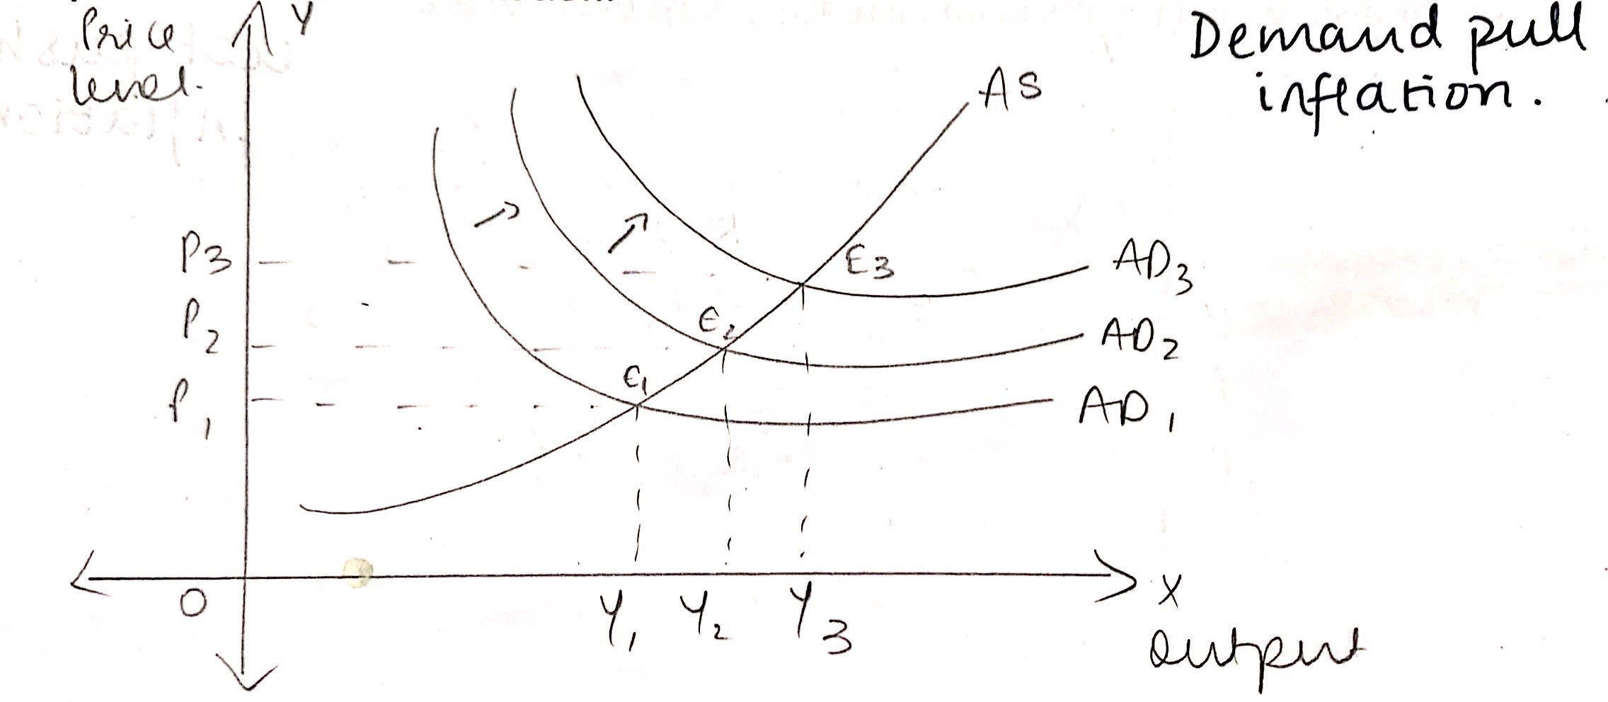

1. **Cost – Push Inflation**

Here, prices may increase even when demand does not increase. The main cause of cost – push inflation is increase in cost of production. The increase in prices of inputs such as labour, increase in profit – margin, increase in material cost or natural/artificial scarcity will result in cost – push inflation.

The main four causes are as follows: -

1. **Oil Price Shock**

In the 70s, the supply shocks causing increase in marginal cost of production became an important factor of cost push inflation. As a result, the crude oil price rose. The rise in oil prices, not only gives rise to inflation but also adversely affects the balance of payments, rising current account deficit of the oil importing countries such as India.

1. **Farm Price Shock**

In India, when monsoon is not adequate or comes very late or when weather conditions are unfavourable, they reduce the supply of agricultural products and raise their prices. These farm products are raw materials for various industries for e.g.: - cotton textile industry, sugar industry, jute industry, agro-based industry etc and as a result when prices of farm products rise, they lead to rise in prices of these goods. This results in food inflation.

1. **Import Price Shock**

When the Indian Rupee depreciates more Rupees are required to buy one US Dollar and therefore in terms of Rupees, imports become costlier. Thus, Indians have to pay higher prices in terms of Rupees when Indian Rupee depreciates against US Dollars. This raises the cost of production of the producers who in turn raise the price of final products. This inflation is the result of import price shock.

1. **Wage Inflation**

When prices rise due to increase in wages it is called wage – push inflation. When trade unions push for higher wages which are not justifiable either because of productivity or cost of living it results in cost push effect. Higher wages in the organised sector influence the wage rate in the unorganised sector also, which results in an increase in cost everywhere.

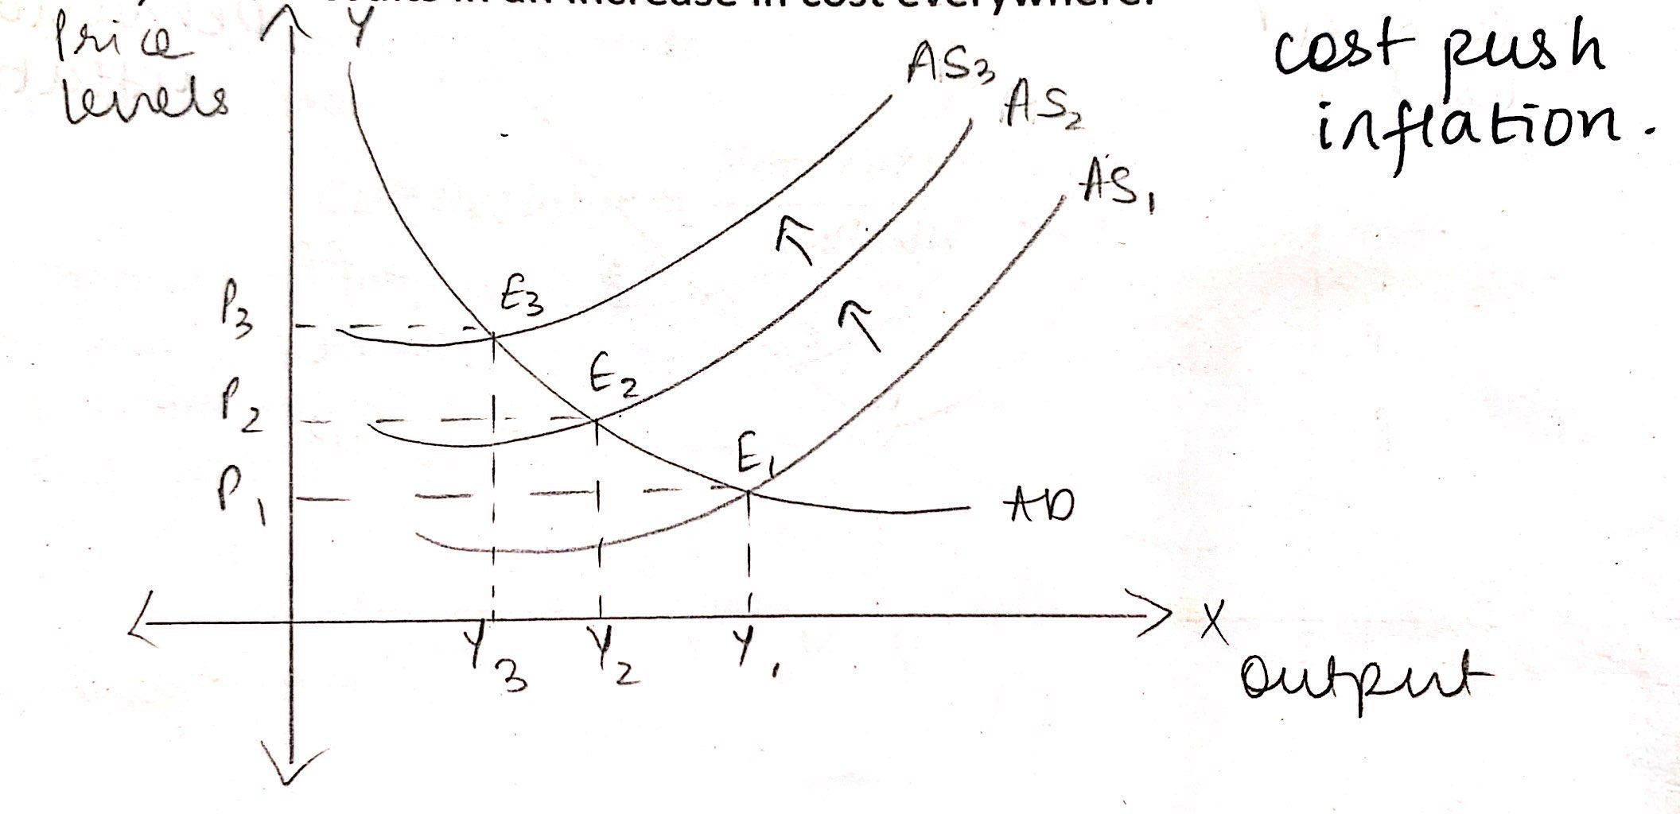

* Effects of Inflation

1. **Investment & Production**

If the inflation occurs in a less than full employment level, it stimulates investment. Increase in price level will bring more profits. Increase in investment results in more production. The positive effect of investment and production will be felt till the economy reaches full employment. Beyond this point, if inflation grows and if uncontrolled then it results into hyperinflation.

1. **Real Income**

Because of inflation, the real income or purchasing power of money declines. There is an inverse relationship between price level and value of money. An increase in price need not always reduce the real income if money income also increases. For e.g.: - a 10% increase in price accompanied by a 10% hike in money income will result in the real money income of people unaffected. During hyperinflation, there is a drastic decline in purchasing power of money. In such times it is said “*People carry the currency to the market in baskets and return with goods in their pockets*.”

1. **Income Distribution**

During inflation, price of all goods & services or of different sectors do not increase at an uniform rate. Investors in financial assets like government bonds or any investments which earn a fixed rate of return, find their real income decreasing and speculator stand to gain.

1. **Employment**

Inflation provides an incentive to invest and produce. Employment opportunities increase with additional investment, thus an inverse relationship is established between inflation and unemployment. This situation is known as ‘Philips Curve’.

1. **Debtors & Creditors**

Money income of the people increases during inflation. Debts and interest contracted earlier remain the same and thus becomes easier for the debtors to settle their obligations. Thus, debtors gain and creditors lose during inflation.

* Measures to Control Inflation

1. **Fiscal Policy – Reducing Fiscal Deficit**

If the total revenue raised by the government through taxation, fees, surpluses from public undertakings is less than the expenditure it incurs on buying goods & services to meet its requirements of defence, civil administration and various welfare activities, there emerges a fiscal deficit.

To reduce fiscal deficit the government can mobilise more resources through taxes, both direct and indirect. In India there is a lot of scope of raising resources through taxation. In both personal and corporate income taxes, there are a large number of unnecessary exemption which lower the effective rate of income tax. It can reduce fiscal deficit by keeping a check on its wasteful and inessential expenditure, especially subsidies to non-poor people.

1. **Monetary Policy – Monetary tightening**

Monetary policy refers to the adoption of suitable policy regarding interest rate and the availability of credit. As an instrument of demand management, monetary policy can work in two ways i.e. it can affect the cost of credit and it can influence credit availability for private business firms.

Let us consider the cost of credit. The higher the rate of interest, the greater the cost of borrowing from the banks by the business firms. As anti-inflationary measure, the rate of interest has to be raised to discourage businessman to borrow more so that less bank credit is created. In India, bank rate has not been generally used but instruments like repo rate and reverse repo rate have been used to manage aggregate demand.

It is noted recently that it is changes in credit availability rather than cost of credit that is more effective instrument. There are several methods, one of them being open market operations. Under open market operations, the Reserve Bank sells Government securities. Those, especially banks, who buy these securities will make payment for them in terms of cash. With their reduced cash reserves, their capacity to lend money will decrease. This will tend to reduce the supply credit or loanable funds by the banks which in turn would tend to reduce aggregate demand.

1. **Supply management through imports**

To correct excess demand relative to aggregate supply, the latter can also be raised by importing goods in short supply. In India, to check the rise in prices of food grains, edible oils, sugar, etc., the Government has often taken steps to increase imports of goods in short supply to enlarge their available supplies. To increase imports of goods in short supply the government can reduce custom duties on them so their imports become cheaper and therefore their imports help in containing inflation. However, when international prices of commodities are high, their imports cannot be very helpful for tackling domestic inflation.

1. **Income policy – freezing wages.**

It is through wage-price spiral that inflation gets momentum. When cost of living rises due to initial rise in prices, workers demand higher wages to compensate for the rise in cost of living. When their wage demands are met, it gives rise to cost-push inflation. And this generates inflationary expectations which add fuel to the fire. To check this vicious circle of wage-chasing prices, an important measure will be to exercise control over wages. However, if wages are raised equal to the increase in the productivity of labour, then there will be no inflationary effect. Thus, the proposal has been to freeze wages in the short run and wages should be linked with the change in level of productivity over a long period of time.

It is thus clear that with the adoption of various monetary, fiscal and other policy measures aggregate demand can be reduced on the one hand and the aggregate supply of output can be increased on the other. This would help in bridging the gap between aggregate demand and aggregate supply which would enable us to contain the inflationary pressures in the economy.

* Philips Curve

Prof A. W. Philips published an article in 1958 based on historical data for UK for about 100 hours. He arrived at a conclusion that there exist an inverse relationship between rate of unemployment and rate of inflation. Thus there exist a trade-off between inflation and unemployment. This is popularly known as ‘Philips Curve’.

This inverse relationship implies a trade-off i.e. for reducing unemployment, higher rate of inflation has to be paid and for reducing the rate of inflation, the unemployment has to be borne.

* **Short – Run Philips Curve**

The short-run Philips curve is downward sloping which explains an inverse relationship between rate of inflation and unemployment. On the basis of this, many economists came to believe that there exist a stable Philips Curve which depicts a predictable inverse relationship between inflation and unemployment. On the basis of a stable Philips Curve for a country they emphasise the trade of that confronts the economic policy makers. This trade-off presents a dilemma for the policy makers – should they choose a higher rate of inflation with lower unemployment or a higher rate of unemployment with a low inflation rate.

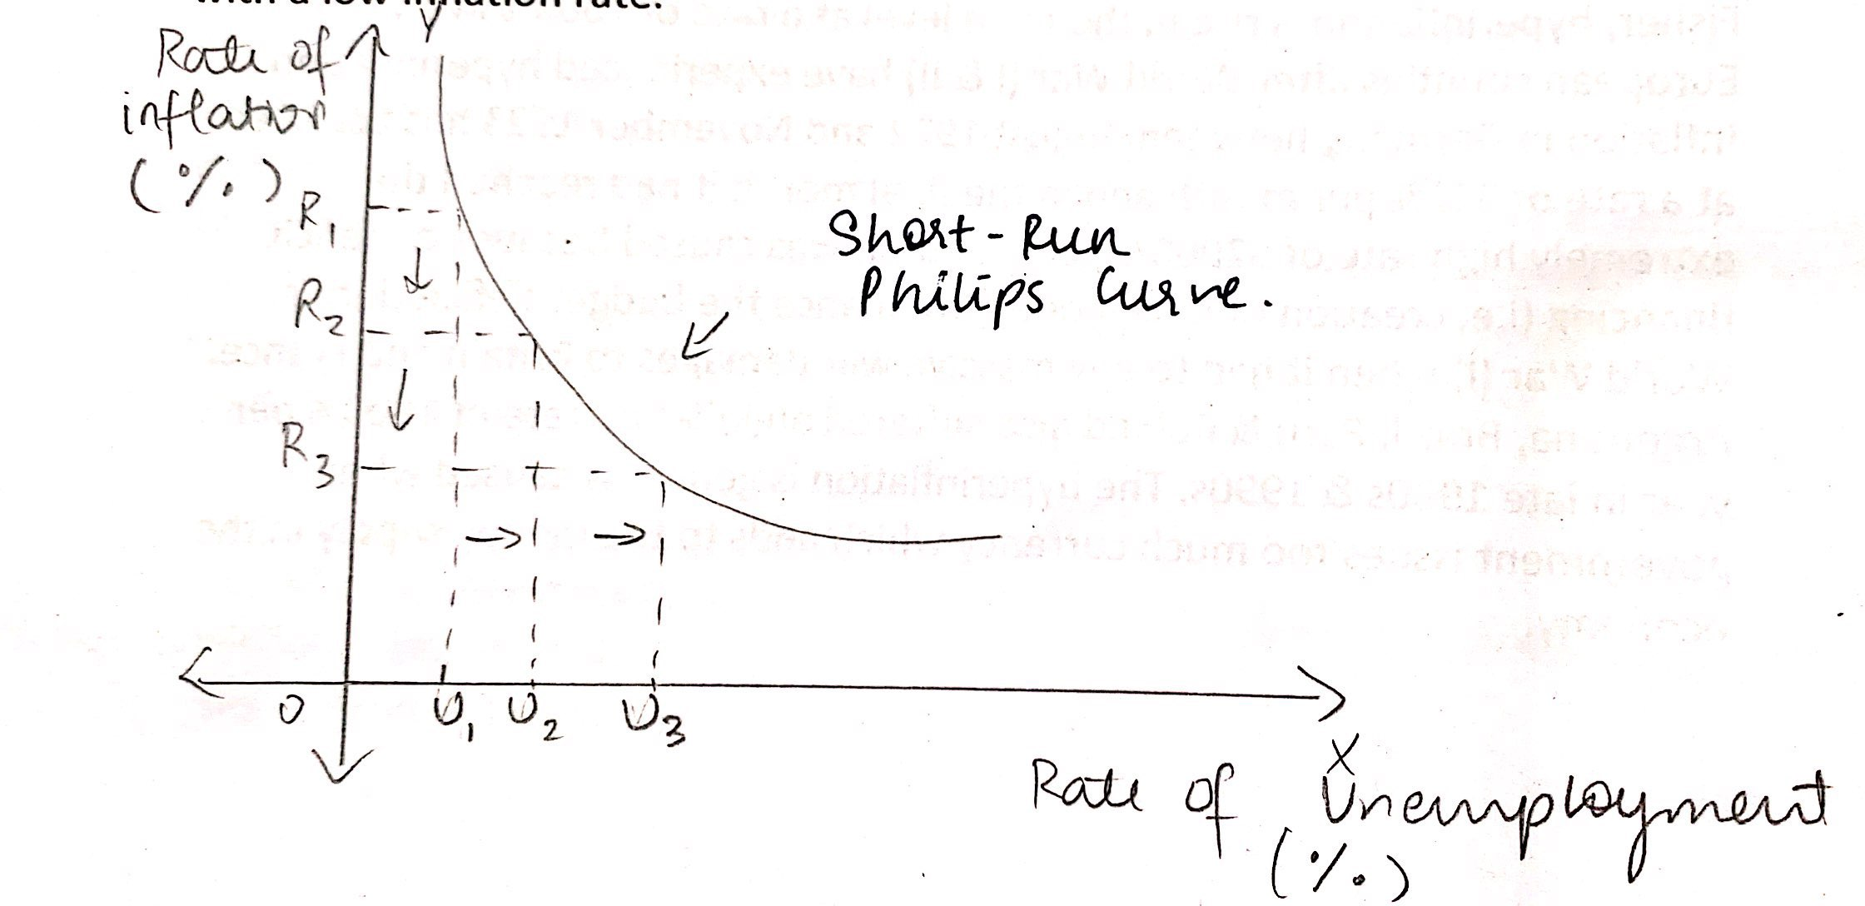

* **Long – Run Philips Curve**

In the long-run, the Philips Curve is a vertical straight line. This implies that in the long run there is a minimum unemployment rate that is consistent with steady inflation. It is termed as “Non Accelerating Inflation Rate of Unemployment” (NAIRU). It is also called as Natural Rate of Unemployment. The long-run Philips Curve is based on the concept of natural rate of unemployment. The natural rate of unemployment is the rate at which in the labour market the current number of unemployed is equal to the number of jobs available. These unemployed workers are not employed for the frictional and structural reasons though the equivalent number of jobs are available for them.

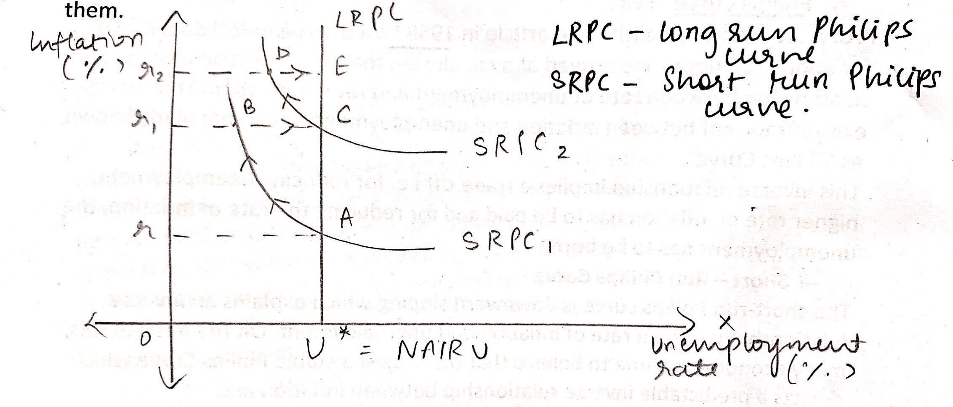

* Hyper Inflation
* **Hyper Inflation and Economic Crisis**

When inflation is strangely high it is called as hyperinflation. A hyperinflation is generally defined as inflation at a rate of 50% or more per month. According to Fisher, hyperinflation is rise in the price level at a rate of 1000% in a year. European counties after World War (I & II) have experienced hyperinflation. Inflation in Germany between August 1922 and November 1923 has occurred at a rate of 322% per month and in the final month it had reached the extremely high rate of 32000% per month. It was caused because of deficit financing (i.e. creation of new money) to finance the budget deficit during World War (I) when it had to pay massive war damages to Britain and France. Argentina, Brazil, Peru & Poland also suffered an inflation rate of 1000% per year in late 1980s & 1990s. The hyperinflation is generally caused when government issues too much currency which adds to the money supply in the economy.

When prices go on increasing upward for some time, people start expecting that prices will rise further and value of money will depreciate. In order to protect themselves from the fall in purchasing power of money in the future, they tried to spend the money now. This raises the aggregate demand for goods in the present.

Businessman increase their purchases of capital goods in anticipation of rise in prices. Thus, inflationary expectations raise the pressure on prices and in this way inflation feeds on itself.

The hyperinflation also arises because of adverse supply shocks which take place because of rise in oil prices. Because of this unemployment rises and GDP falls. To get rid of unemployment the central bank increases the supply of money to raise aggregate demand. This higher aggregate demand succeeds in eliminating unemployment but generates higher inflation.

* **Measures to control hyper inflation**

The government succeeded in controlling Hyper Inflation through the adoption of stabilization policy. This is done through: -

1. By cutting down government expenditures and subsidies and raising taxes which will result a slow-down in growth of money and control of inflation
2. The government can make announcement that the budget deficit of the government will not be automatically monetized. This means that the government should assure that it will finance its expenditure through taxes and not resort to deficit financing.

* Stagflation

The term stagflation refers to an economic situation in which a high rate of inflation occurs simultaneously with a high rate of unemployment. It is characterised with low economic growth, increasing unemployment and high rate of inflation. It goes against the conclusion of Philips Curve i.e. the inverse relationship between inflation and unemployment. Here, we have a continuous increase in price level and also increasing rate of unemployment.

US economy suffered from stagflation during 1973-1975 when GDP shrank and inflation remained high crossing double digits and the rate of unemployment was nearly 9% during 1973-1975. This situation was also seen in other countries such as France, Germany and Britain.

* Causes of Stagflation

1. **Advance Supply Shock**

USA and some other developed countries suffered stagflation mainly due to a sudden increase in crude oil prices in 1973 by OPEC.

1. **Monetary Shocks**

Contractionary monetary policy whereby more money is pumped into the economy at a lower cost results in inflation.

1. **Deficit Finance**

Government expenditure more than its revenue leads to more demand for goods & services resulting in higher prices.

1. **The shortage of supply in Agricultural products**

Reduction in domestic supply of agricultural products raises the average cost of production and increases the prices. This results in shift in aggregate supply curve to the left.

1. **Social Benefits**

Social Benefits such as unemployment benefits, free supply of goods & services to the poor, minimum basic income scheme, food security schemes etc provide income to the poor with no obligation to work. It creates more demand (inflation) and shortage of goods & services.

1. **Policy Changes**

Democratic governments with an eye on vote bank may introduce popular policy measures such as farmers debt waiver, free electricity, increase in wages & salaries, increase in procurement prices. All these measures increase the demand with less than corresponding increase in production of goods & services.

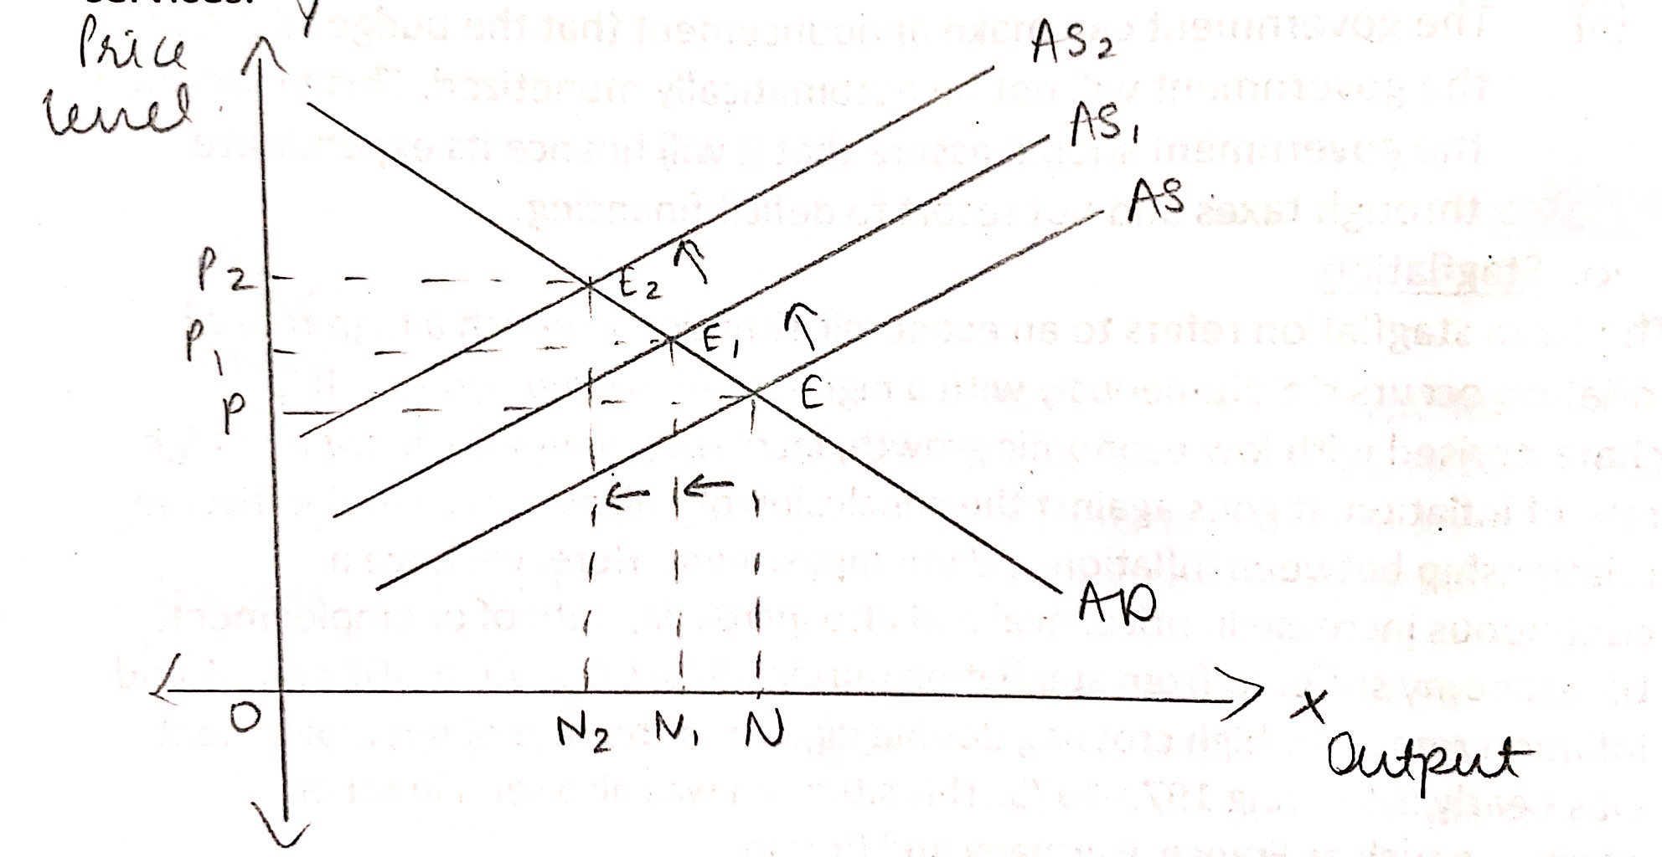

**MONEY SUPPLY**

Money supply refers to the stock of money held by people in spendable form. It is the total stock of money which is available to a society for use. Money supply is a stock concept because it is calculated at a point of time. Money supply always refers to amount of money held by the public such as households, firms and institutions other than banks and the government. The supply of money is composed of: -

1. Currency with the public.
2. Demand Deposits with the public.
3. Currency with the public

In order to arrive at total currency with the public in India we add following items: -

* Currency notes issued by RBI
* No of Rupee notes and coins in circulation.
* Small coins in circulation.

1. Demand deposits with public.

The demand deposits held by the public are also known as bank money. Demand deposits in the banks are those deposits which can be withdrawn by drawing checks on them. Through checks these deposits can be transferred to others for making payments.

* Measures/Constituents of Money Supply

There are four measures of money supply.

1. **Narrow Money M1**

where

C is the currency with public

DD is the demand deposits with public

OD denotes other deposits help by public with RBI

C comprises of

1. Notes in circulation
2. Circulation of rupee coins
3. Cash reserves with all banks

OD comprises of

1. Deposits with financial institutions such as UTI, IDBI, IFCI, etc.
2. Demand deposits of foreign central banks and foreign governments.
3. Demand Deposits of IMF and World Bank.
4. **M2**

M2 is a broader concept of Money Supply than M1 in India. In addition to three items of M1, M2 includes saving deposits with the post office savings banks. Thus,

1. **M3**

It is a broad concept of money supply. In addition to M1, M3 includes time deposits with banks. Thus,

1. **M4**

The measure of M4 includes not only all the items of M3 but also the total deposits with the post office savings organization. It excludes the contributions by the public to the National Saving Certificate.

* Determinants of Money Supply

The Money supply comprises of currency held by the public (CP) and demand deposits with the bank (DD)

There are two factors which determines the money supply in the economy.

1. High Powered money (H)
2. Money Multiplier (m)
3. **High Powered Money/Base Money (H)**

It consists of currency issued by the government and RBI (CP) and a part is held by the banks as reserves (R). Therefore, High Powered Money is the sum of currency held by the public and reserves held by the banks.

The relationship between money supply and high powered money is determined by money multiplier.

The amount of high powered money is fixed by RBI. Changes in high powered money are the result of decisions of RBI or government of India.

1. **Money Multiplier (m)**

It is a ratio of total money supply (M) to the stock of high powered money.

It shows the degree to which money supply is expanded as a result of increase in high powered money. Therefore,

Thus, money supply is determined by the size of money multiplier (m) and amount of high powered money (H).

* **Derivation**

The money supply comprises of currency held by the public CP) and demand deposits with the bank (DD)

The public hold the amount of currency in a certain rate of demand deposits with the bank. This is known as currency deposit ratio (k).

Thus,

……………..1

Consider high powered money (H)

…………..2

‘R’ represents revenue which banks keep as a ratio of their deposits which is known as ‘r’ i.e. Cash Reserve Ratio (CRR)

From 3

The money multiplier is a ratio of Money Supply to High Powered money.

The money supply (M)

where

H is high powered money

M is the money supply

The money supply will increase when: -

1. The supply of high powered money (H) increases.
2. The currency deposit ratio (k) decreases.
3. The reserve ratio of banks ® decreases.

* **CRR and Deposit Multiplier**

Under the fractional reserve system, with a small increase in cash reserves with the bank, they are able to create multiple increase in total demand deposit, which is an important part of money supply.

The ratio of change in total deposits to a change in reserve is known as ‘deposit multiplier’

ΔDD – Changes in demand deposits

ΔR – Changes in reserves

The value of deposit multiplier is the reciprocal of CRR

If CRR is 10% of deposits, then is the deposit multiplier

This shows for every Rs. 100 increase in cash reserve with the bank, there will be expansion in demand deposits of banks by Rs. 1000.

* **Currency Deposit Ratio and Multiplier.**

With the increase in the reserves of the banks, demand deposits and money supply do not increase to the full extent of deposit multiplier. This is because the public does not hold all its money in the form of demand deposits with the banks. During the process of credit creation of banks, some currency leaks out from the banks. The greater the leakage of currency, the lower will be the money multiplier.

* **Credit Multiplier.**

It measures the extent by which the banking system create credit as a result of new increase in primary deposits.

ΔC denotes change in credit

ΔR denotes change in reserve

Since,

Also,

Thus,

* Velocity of circulation of money.

It refers to the amount of units of money circulated in the economy during a given period of time. It refers to how fast money passes from one person to another.

To know money supply over a period of time, we should multiply the stock of money (M) by the velocity of circulation of money.

M – Stock of money

V – Velocity of circulation

There are two types of velocity of money: -

1. Transaction Velocity
2. Income Velocity
3. **Transaction Velocity**

It is a ratio of annual volume of transaction to the stock of money.

For e.g.: - If the stock of money is Rs. 5000 crores and the transactions are conducted of Rs. 100,000 crores then the transaction velocity is 20. Which means a given unit of money say rupee 1 performs the function of Rs. 20.

Factors affecting Transaction Velocity: -

1. Volume of Production and trade

With a constant supply of money, the velocity will be more when economy produces more goods and thus it has more transactions.

1. Savings

If people increase their savings, less money is spent which will bring down the velocity.

1. Changes in Price Level

During the prosperity period, economic activities increase and price level also increases. This results in higher velocity.

1. Regularity and Certainty of Income Receipts

If income is received in quick intervals such as daily or weekly basis, the velocity is very high. If income receipts are not certain, people will become cautious, they will spend carefully which will bring down the velocity of money.

1. **Income Velocity of Money**

It refers to average number of times a unit of money is used for making payments for final goods & services. It is a ratio of GNP to money stock.

For e.g.: - If GNP is Rs. 50,000 crores and money stock is Rs. 10, 000 crores then the income velocity of money is 5.

The income velocity is always lower than the transaction velocity because it confines only to final goods & services.

Factors affecting Income Velocity: -

1. Growth of GNP

An increase in GNP with an increase in quantity of money will increase income velocity and vice-versa.

1. Quantity of Money Supply

If the stock of money increases faster than final goods & services, the income velocity falls because there are less goods & services available to purchase.

**FOREIGN EXCHANGE RATE**

The exchange rate is a price of a country’s currency in terms of another country’s currency, for e.g.: 1 US Dollar is equal to INR 71.15 or INR 94.49 is equal to 1 pound.

* **Flexible and Fixed Exchange Rate System**

The system of exchange rate in which the value of a currency is allowed to adjust freely or to float as determined by demand for and supply of foreign exchange is known as ‘*flexible exchange rate system*’. It is also known as ‘*floating exchange system*’.

Under the fixed exchange rate system, the exchange rate is fixed by the government or central bank of a country. At the fixed exchange rate, if there is disequilibrium in the balance of payments, giving rise to either excess demand or excess supply of foreign exchange, the central bank of a country has to buy and sell the required quantities of foreign exchange to eliminate the excess demand or supply.

* **Manage Float System in India**

In order to prevent large appreciation and depreciation of Indian Rupee, RBI intervenes to ensure that the exchange rate should remain within reasonable limit.

When the Rupee is depreciating, RBI sells dollars from it’s reserves of foreign exchange. This increases the supply of dollars in the market and prevents depreciation of Rupee.

When Rupee is appreciated, RBI buys dollars from the market. This reduces the supply of dollars in foreign exchange market which prevents the appreciation of Rupee.

Such a system has been adopted by India where the central bank of a country intervenes in foreign exchange market to prevent large fluctuations in exchange rate which is managed by the central bank. This system is known as ‘manage float system’.

* **Concepts of Exchange Rate**

1. Nominal Exchange Rate (NER)

It is quoted as the number of units of a domestic currency required to purchase 1 unit of foreign currency. The exchange rate of Rupees per Dollar or Rupees per Euro is known as nominal exchange rate.

1. Nominal Effective Exchange Rate (NEER)

It is the weighted average of nominal exchange rate where the weights used are the shares of the trading partners in the foreign trade of a country.

Formula:

where

W is the weights

1. Real Exchange Rate (RER)

It measures the relative price of two currencies after adjusting for price levels prevailing within two countries.

The real exchange rate (RER) between Indian Rupee and US Dollar is defined as Rupee price of a basket of goods in Indian relative to a dollar price of the same basket of goods in US.

1. Real Effective Exchange Rate (REER)

It is a weighted average of real exchange rate with all it’s trading partners. The shares of different countries in its total trade are used as weights.

In India, five country’s REER is prepared and the shares of major trading partners such as UK, USA, Japan, and other European countries with India are used as weights for calculating REER.

* **Determination of Exchange Rate**

